**Reference Ontology**

**Mind Map**

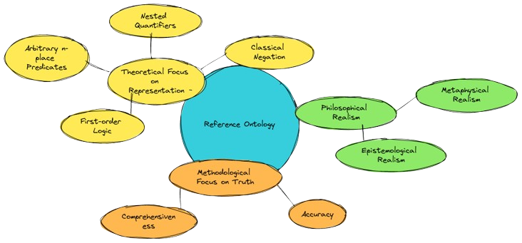

Done By:

Rishav Goswami

RA2411003011303

**Engineering Application Ontology Mind Map**

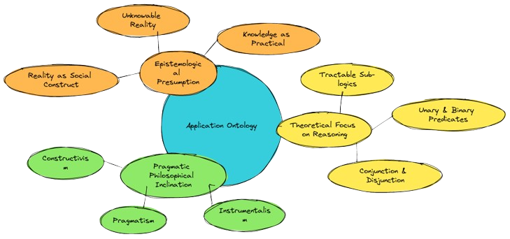

Done By:-

Rishav Goswami

RA2411003011303

**Product Life Cycle Ontology**

**Mind Map**

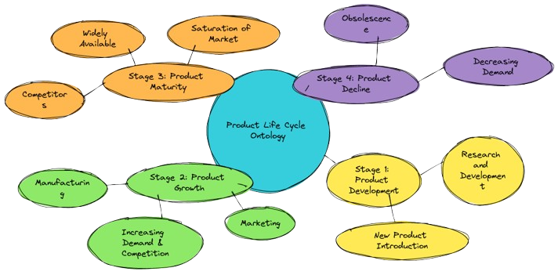

Done By:-

Rishav Goswami

RA2411003011303